**Web Programming**

**(LAB Session -08)**

* **Working with JavaScript Event**

**Q-A) Create a JavaScript program to work with below events:** • **Write a sample program that prints alert message in response to browser events: onload, ononline, onoffline, onresize.**

**Output:**

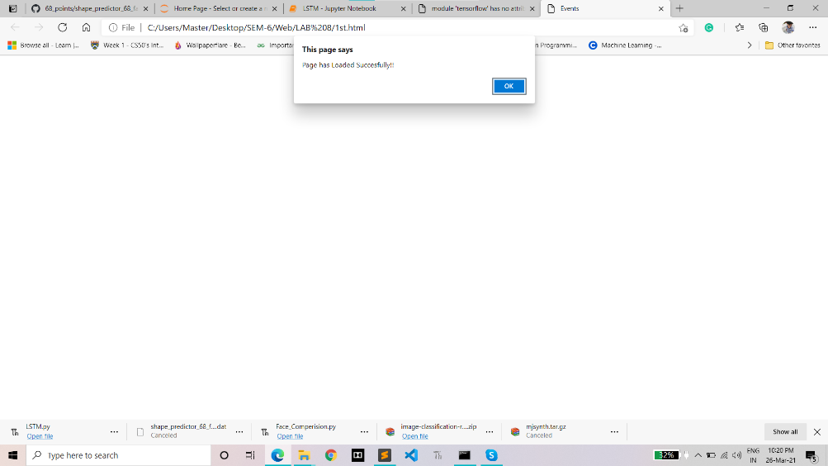

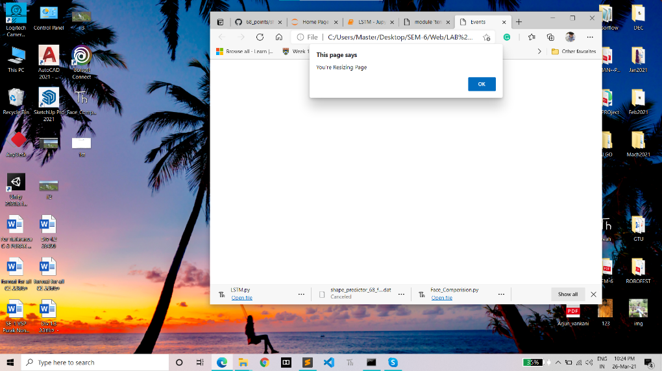

**CODE:**

**<!DOCTYPE html>**

**<html>**

**<head>**

**<title>Events</title>**

**</head>**

**<body onload="loadPage()" onoffline="offlineEvent()" ononline="onlineEvent()" onresize="resizePage()">**

**<script>**

**function loadPage(){**

**alert("Page has Loaded Succesfully!!");**

**}**

**function offlineEvent() {**

**alert("You're Offline, Connect Your Phone With Internet");**

**}**

**function onlineEvent(){**

**alert("You're Online, Continue To Your Work");**

**}**

**function resizePage(){**

**alert("You're Resizing Page");**

**}**

**</script>**

**</body>**

**</html>**

**Q-B) Write a sample program that prints appropriate alert message on mouse events.**

**OutPut:**

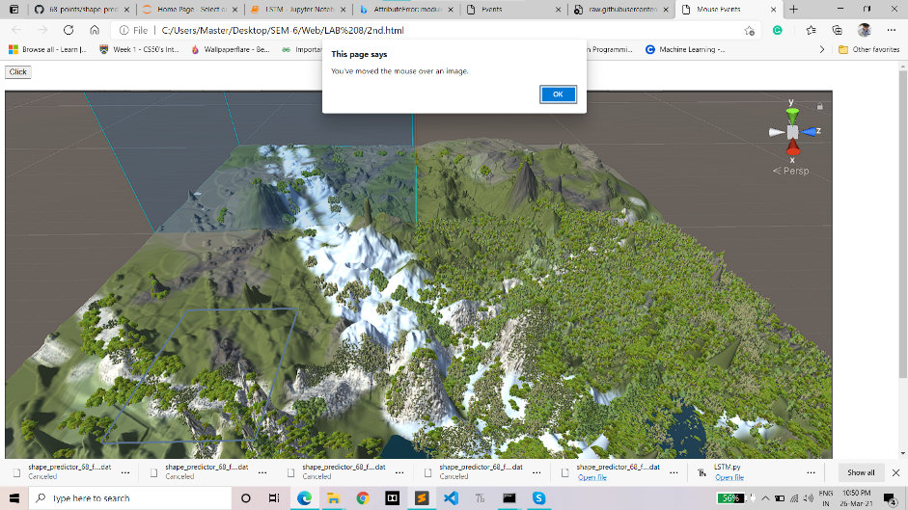

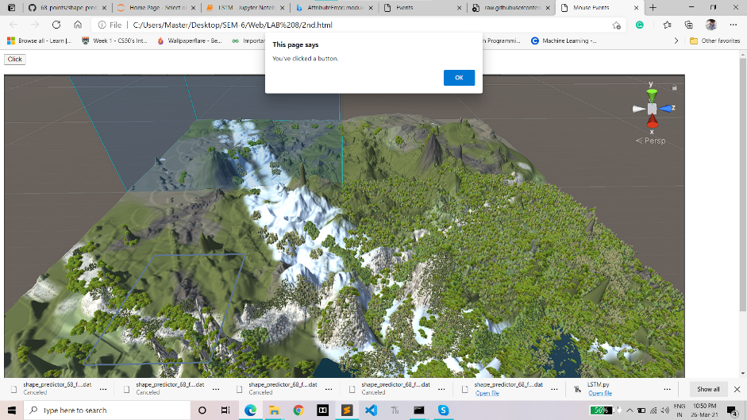

**CODE:**

**<!DOCTYPE html>**

**<html>**

**<head>**

**<title>Mouse Events</title>**

**</head>**

**<body>**

**<button onclick="clickEvent()">Click</button><br><br>**

**<img src="ii3.png" alt="Image" width="1400px" height="750px" onmouseover="mouseOverEvent()"><br><br>**

**<script>**

**function clickEvent() {**

**alert("You've clicked a button.");**

**}**

**function mouseOverEvent() {**

**alert("You've moved the mouse over an image.")**

**}**

**function mouseWheelEvent() {**

**alert("You've rolled the mouse wheel.")**

**}**

**</script>**

**</body>**

**</html>**

**Q-C) Write a sample program that prints appropriate alert message on any three keyboard events.**

**OutPut:**

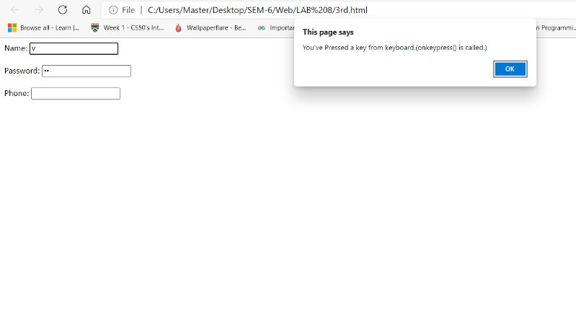

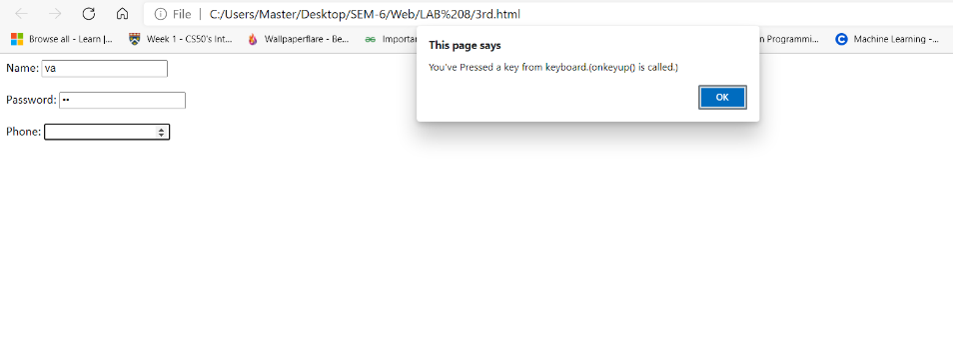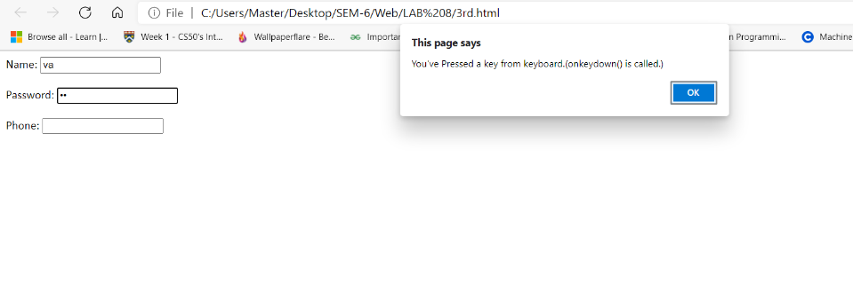

**CODE:**

**<!DOCTYPE html>**

**<html>**

**<head>**

**<title>Keyboard events</title>**

**</head>**

**<body>**

**<form action="">**

**<label for="name">Name: </label>**

**<input type="text" id="name"**

**onkeypress="keyPressEvent()"><br><br>**

**<label for="password">Password: </label>**

**<input type="password" id="password"**

**onkeydown="keyDownEvent()"><br><br>**

**<label for="phone">Phone: </label>**

**<input type="number" id="phone" onkeyup="keyUpEvent()">**

**</form>**

**<script>**

**function keyPressEvent() {**

**alert("You've Pressed a key from keyboard.(onkeypress() is called.)");**

**}**

**function keyDownEvent() {**

**alert("You've Pressed a key from keyboard.(onkeydown() is called.)");**

**}**

**function keyUpEvent() {**

**alert("You've Pressed a key from keyboard.(onkeyup() is called.)");**

**}**

**</script>**

**</body>**

**</html>**

**Q-D) Write a sample program that prints appropriate alert message on media events.**

**OutPut:**

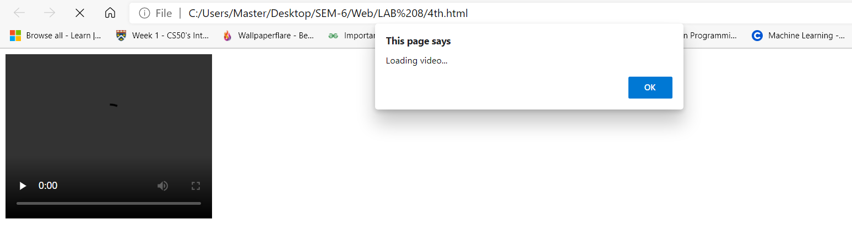

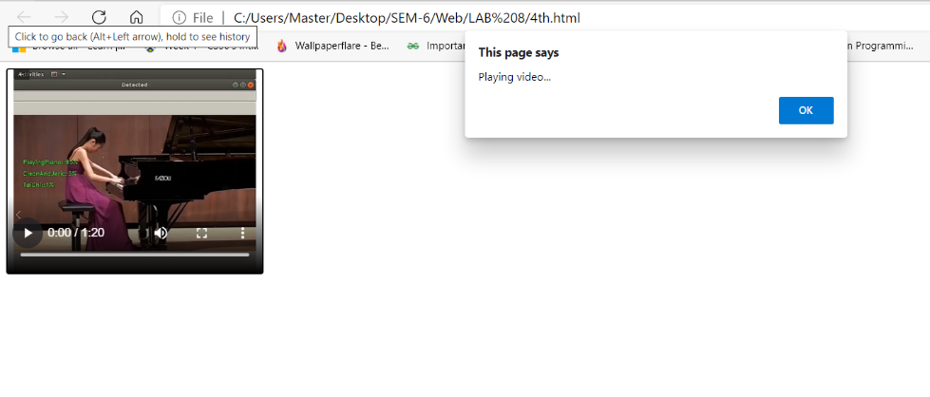

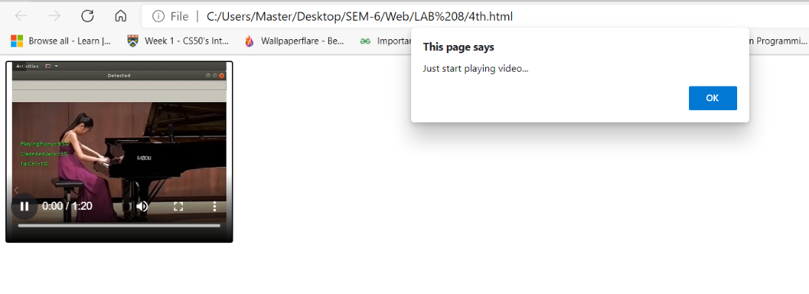

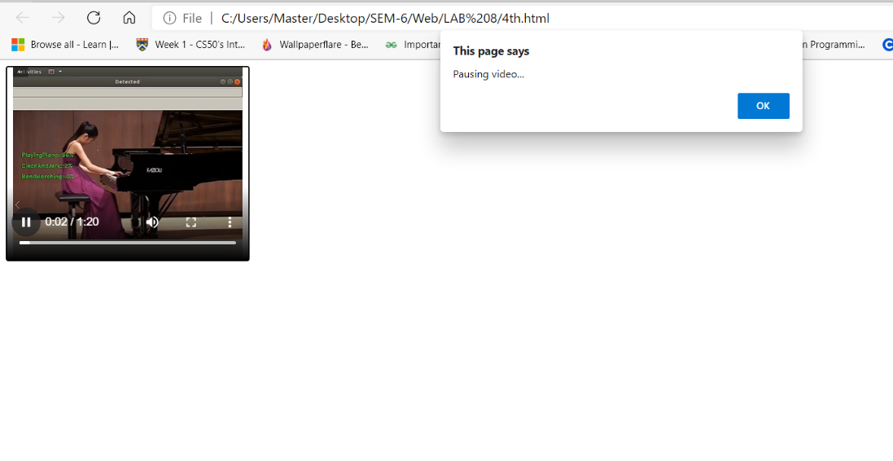

**CODE:**

**<!DOCTYPE html>**

**<html>**

**<head>**

**<title>Media Event</title>**

**<script>**

**function playEvent() {**

**alert("Playing video...");**

**}**

**function pauseEvent() {**

**alert("Pausing video...");**

**}**

**function loadEvent() {**

**alert("Loading video...");**

**}**

**function endEvent() {**

**alert("Ending video...")**

**}**

**Function playingEvent() {**

**alert("Just start playing video...");**

**}**

**</script>**

**</head>**

**<body>**

**<video width="300" height="240" controls onloadeddata="loadEvent()" onplay="playEvent()"**

**onpause="pauseEvent()" onended="endEvent()"**

**onplaying="playingEvent()">**

**<source src="Human.mp4" type="video/mp4">**

**<source src="Human.ogg" type="video/ogg">**

**Your browser does not support the video tag.**

**</video>**

**</body>**

**</html>**